https://techies.app/

https://www.alliancetek.com/

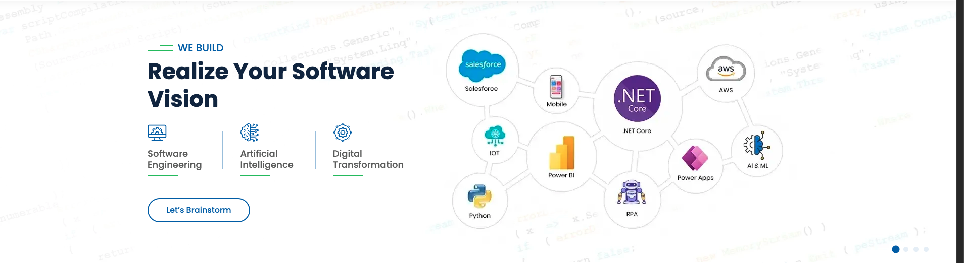

https://hashthink.com/


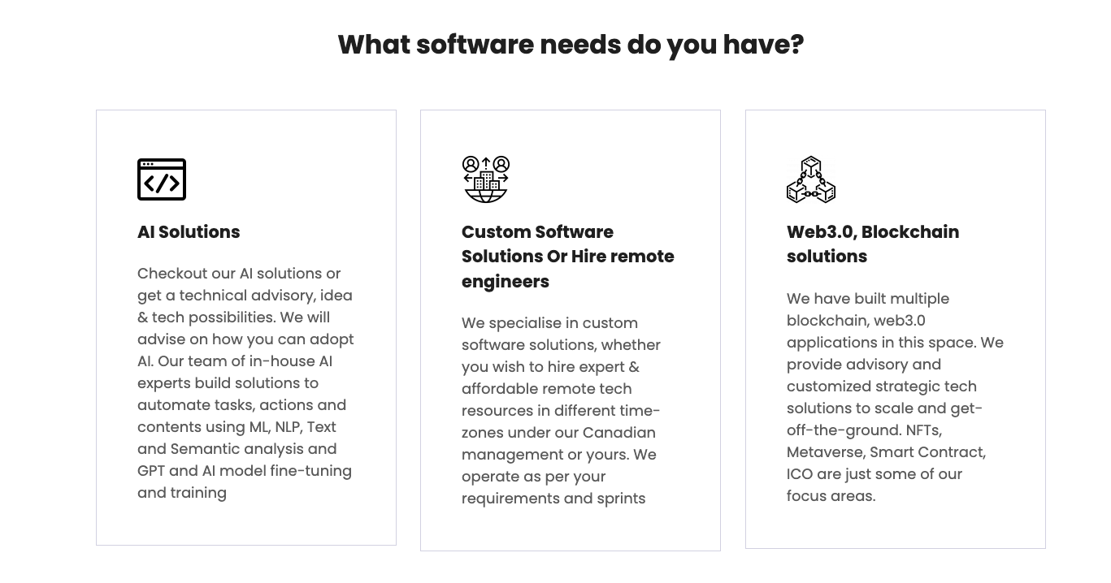
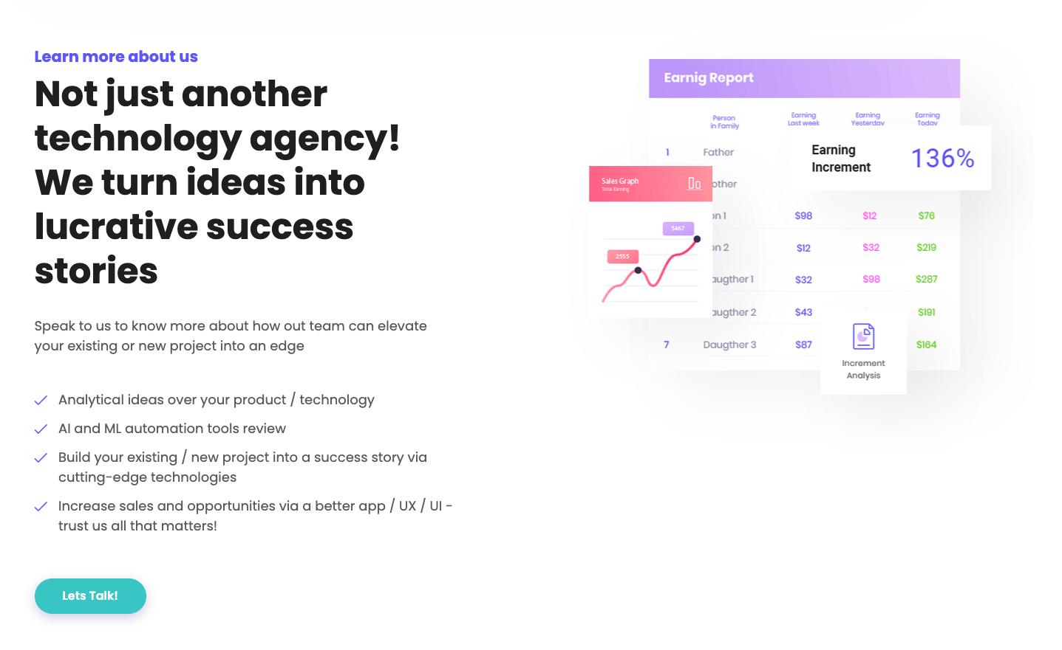
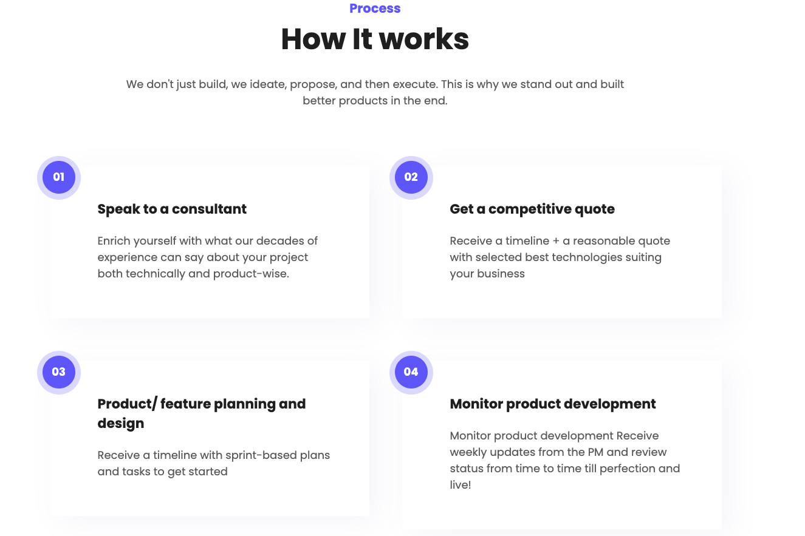
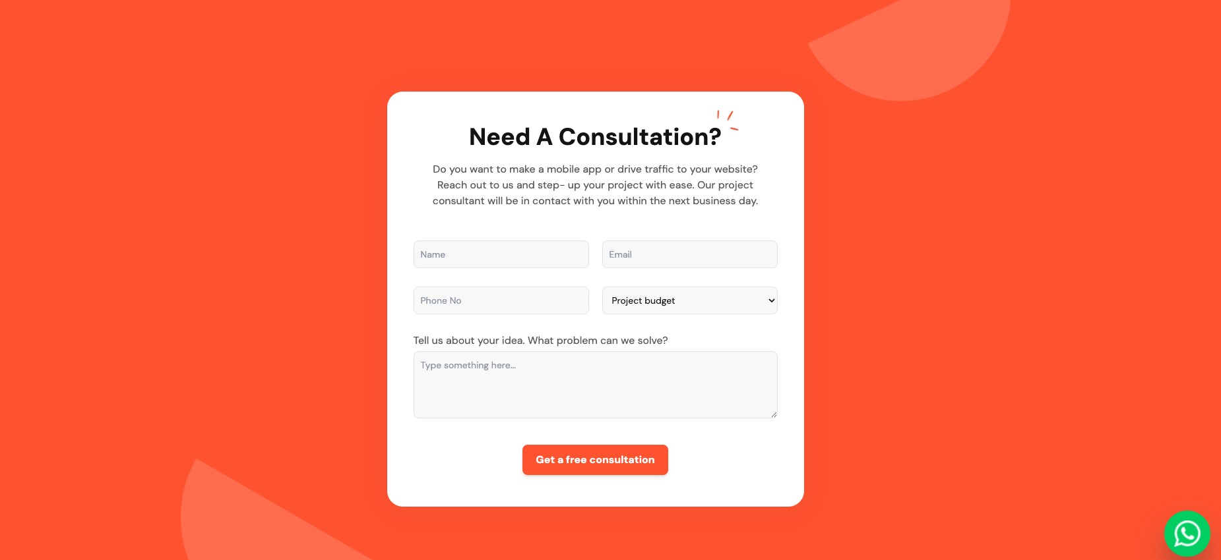
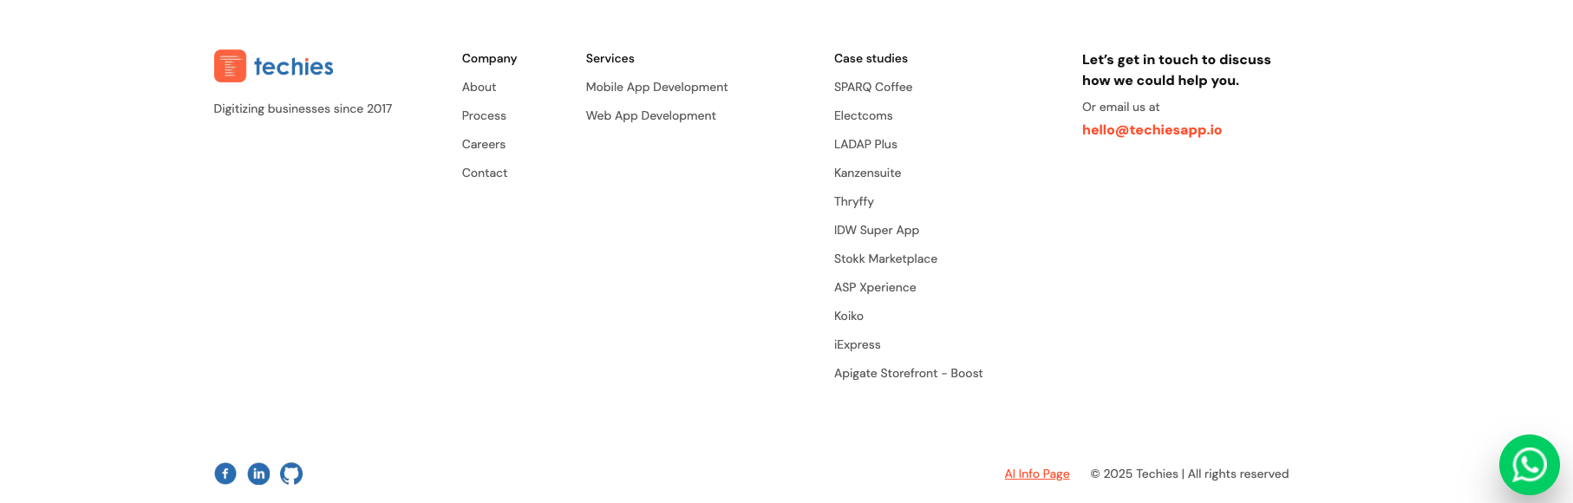

https://techies.app/

https://www.lizard.global/services/cost-estimator

https://www.grtech.com/entriphi >>>>>for product design page
https://www.grtech.com/custom-software-development >>.>>service design page
https://www.grtech.com/case-study/paradise-valley-community-college-student-orientation-system >>>>>>case study
https://www.grtech.com/blog >>>>>blog
https://techies.app/about >>>>>about
https://www.grtech.com/custom-software-development#contact

